

Template for Identifying Structural Advantage and Disadvantage by Population Groups & Dimensions
(v.2)
  - Spain, mobility and transport sector

Olga Kolotouchkina & Paloma Piqueiras, UCM


Views and opinions expressed are however those of the author(s) only and do not necessarily reflect those of the European Union or [name of the granting authority]. Neither the European Union nor the granting authority can be held responsible for them.
Purpose
The purpose of this template is to identify groups which can avail of existing policy interventions (structurally advantaged) and those that cannot avail of existing policy interventions and/or are negatively impacted by the policy intervention itself (structurally disadvantaged).
To complete this template it is ok to combine your current knowledge and understanding with basic research e.g. finding out what quant data is available, listing factors need for calculation w/o doing actual calculation, taking high level points from executive summaries of key reports.

As a first pass please give this approx. 1 day– it is sufficient to complete it to the best of your ability in that timeframe, clearly highlighting what requires further research.

Section 1
Detail existing policy intervention for your case study area
The MOVES III efficient and sustainable mobility program (Instituto para la Diversificación y Ahorro de la Energía (IDAE, n.d.) is a Spanish government initiative aimed at promoting electric mobility by providing financial incentives for the purchase of electric vehicles and the installation of charging infrastructure. Launched in April 2021 by the Royal Decree 266/2021 of April 13th and coordinated by the Institute for Energy Diversification and Saving (IDAE) within the framework of the National Recovery, Transformation, and Resilience Plan (PRTR), the program is part of Spain’s national strategy to support the transition to sustainable transport and reduce carbon emissions. Spain’s autonomous communities ensure regional implementation and local adaptation of the program.
Initially set to run until 2023, with a budget of 400 million euros, the budget has been increased to 1,735 million euros and the program extended to December 2025.
Key Features of MOVES III:
- Subsidies for electric vehicles through grants available for individuals, businesses, and public administrations to buy electric, plug-in hybrid, and fuel cell vehicles. Up to €9,000 (with vehicle scrappage) for fuel cell and electric vans (up to €7,000 without vehicle scrappage); up to €7,000 (with vehicle scrappage) for electric passenger cars and up to €1,300 for electric motorcycles. While individuals can get subsidies for 1 vehicle, corporate fleets can be subsidized for 250 vehicles.
- Incentives for charging Infrastructure through funding provided for installing private and public charging stations, including residential, workplace, and fast-charging networks. The funding covers up to 70% of the cost of charging points for individuals and SMEs. For residents of municipalities with populations below 5,000 people, the funding covers up to 80%.
Both the subsidies and incentives are granted up to 2-4 years after the purchase of the vehicle and charging infrastructure installation.
Section 2
The purchase of the electric vehicle or the interest in installing a chagrin point is the only condition required to access the MOVES III subsidy, however three specific groups are entitled to an additional 10% subsidy:
- People with limb disability who need to make specific adaptations to their electric vehicles;
- Self-employed taxi or shared mobility drivers
- Residents of municipalities with population below 5,000 people.

- Benefits and Costs of Access/No access to policy intervention –
  - Based on your knowledge and understanding list key benefits of accessing the policy intervention (e.g. reduced energy costs/earning money from selling to the grid).
Subsidies for electric vehicles through grants are universally available for individuals, businesses, and public administrations to buy electric, plug-in hybrid, and fuel cell vehicles. Up to €9,000 (with vehicle scrappage) for fuel cell and electric vans (up to €7,000 without vehicle scrappage); up to €7,000 (with vehicle scrappage) for electric passenger cars and up to €1,300 for electric motorcycles. While individuals can get subsidy for 1 vehicle, corporate fleets can be subsidized for 250 vehicles.
  - Based on your knowledge and understanding list key costs of
- not accessing the policy intervention
- the potential future costs in the next 10 years of not accessing the policy intervention (e.g. paying additional road tax; subject to fluctuating energy costs)

Higher cost of electric vehicles
  - Assess outcome – note the relationship between those who can and those who cannot access the policy intervention – is it mutually beneficial? Does it reinforce structural disadvantage?
Complete the sentences –

Those who can access the policy intervention are advantaged in reduced EV costs. Those who cannot access the plan pay higher costs. The relationship between those who can and cannot access the policy intervention is the difference between those who can or cannot afford the purchase of an electric vehicle.

Section 2b – Advantaged Groups
- Some policy interventions are in line with broader environmental and social objectives. Some policy interventions are out of line with broader environmental and social objectives e.g. the OECD have warned that existing policies re electric vehicle purchase risk reinforcing a car dependent system. We do need electric vehicles but how the fleet is structured needs to be further considered e.g. there needs to be large scale switch to public transport and shared mobility fleets.
The share of EV was 11.4% in 2024, showing a 0.6 decrease as compared to 2023. Madrid, Cataluña and Valencia regions accounted for over 45% of total sales. A total of 151 BEV models and 122 PHEV models were registered in 2024 . Tesla model 3 and Y, and Mercedes GLC 300 accounted for over 40% of total sales (ANFAC, 2025). The average price range of these models is €48.000-70.000. Owners of these EV models are predominantly male, with an average income over €100.000 (Almarza, 2023).

Regional registration of EV in 2024 (ANFAC, 2025)
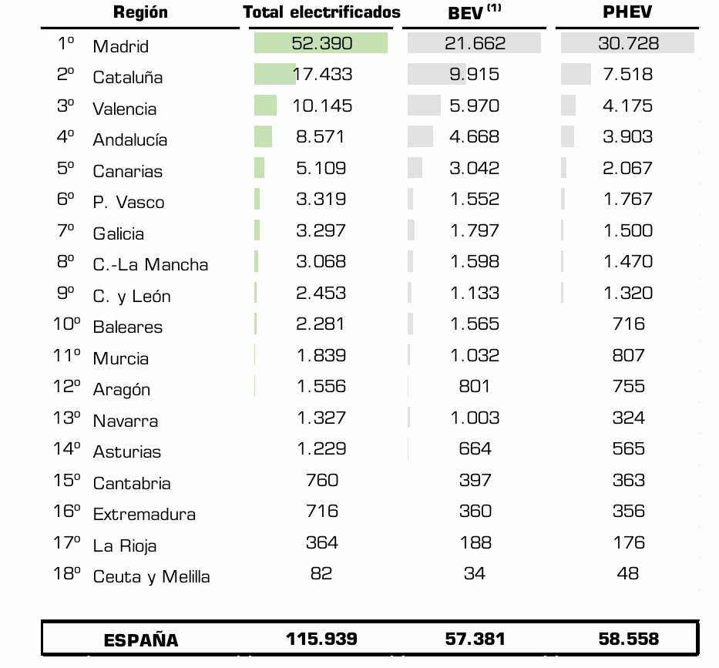

Ranking of BEV by brand registered in Spain in 2024 (ANFAC, 2025).
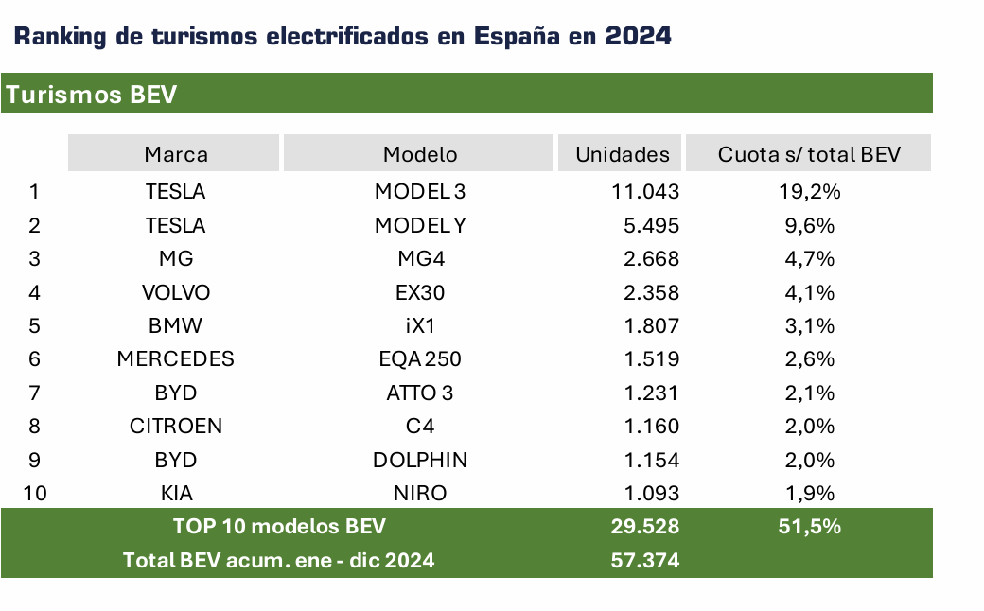
Ranking of PHEV by brand registered in Spain in 2024 (ANFAC, 2025).
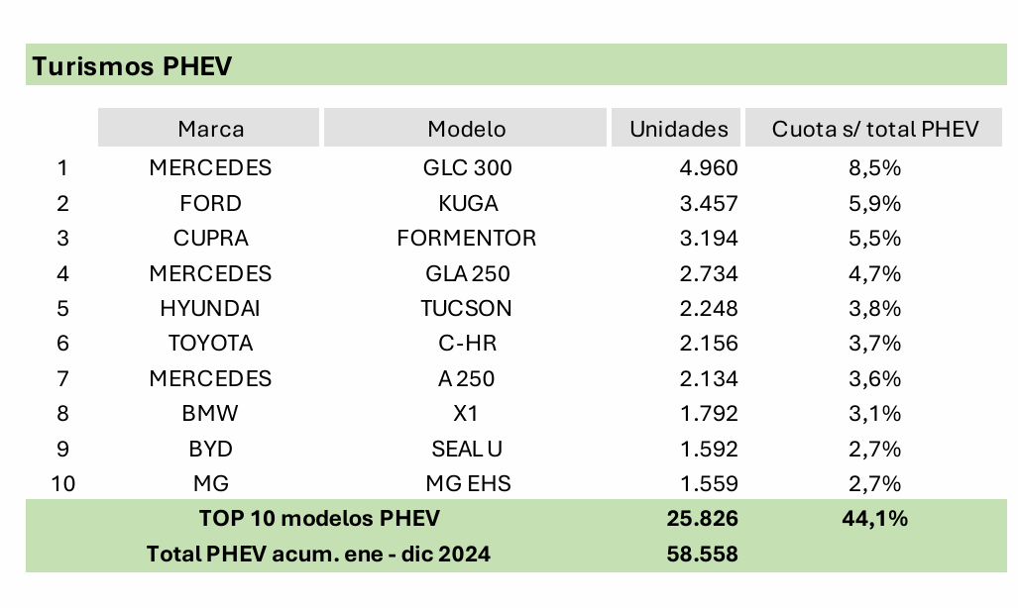

If the policy intervention under consideration is out of line with best practice - identify who is most in need of it regardless of whether or not the wider best-practice, eco-social, infrastructure is in place. For example, people who life 20km outside an urban setting will likely always need to own a vehicle for private use. These people are most in need of switching to an electric vehicle. The rural/urban divide is thus very important.
Among the 31 million vehicles registered in Spain, almost 30% do not have an environmental label of the DGT (General Traffic Authority), meaning that the engines of these vehicles are old and harmful for the environment (Amadoz, 2024). Spanish regulation forbids the access of those vehicles to low-emission zones in cities with population over 50.000. The urban population in Spain accounts for over 80% (Statista, 2024).
This will only apply to certain items – arguably everyone needs a well-insulated home, but not everyone needs an electric vehicle for private use.
Combining this with the key factor (q1) if possible, outline the approximate demographic profile of those that can access the policy intervention – ADVANTAGED group – by gender and age.
The only condition for accessing MOVES III plan is the purchase of an electric vehicle or the installation of a charging point.
Only if relevant - separate those who are most in need of the item from those who wouldn’t need the item (e.g. if active, public and shared mobility schemes were provided).
If everyone needs the item just identify % of population that could (theoretically) access the policy intervention.
If relevant quantitative data is not available – just list what quant data is available and provide qualitative description of cohort that can access the policy intervention. For sample list of available quantitative data please see Appendix A – The list includes some data sets that are Ireland specific (Central Statistics Office – CSO) but can be used as starting point of what is potentially available on a national level. EU SILC and other sources available on Eurostat database are also included on the list.
There is no such specific data on the Spanish case, but the following statistics may help understand the national situation:
- Basic data:
  - Population: 49,153,849
  - GDP: The country's gross domestic product grew by 0.6% in the first quarter of 2025 compared to the previous quarter. This rate is 0.01% lower than that of the fourth quarter of 2024, when it was 0.7%. The year-on-year GDP growth was 2.8%, 0.5% lower than that of the fourth quarter of 2024, when it was 3.3%. GDP in the first quarter of 2025 was €411.366 billion, ranking Spain as the 12th largest economy in the world (the fourth largest economy in the Eurozone) (Expansión, 2025).
  - Employed (activity rate): 21,7 million (58,5% of the total population)
  - Unemployed (unemployment rate): 2,7 million (11,36%)
Minimum wage per month: 1.184 euros
People earning the minimum wage and their profile: Between 2.3 and 2.5 million workers (13.7% of the country's salaried population) (Onda Cero, 2024). The most common profile of those earning the minimum interprofessional wage (SMI) is a woman aged 25 to 55 who works in the services sector with a permanent contract and lives in Andalusia, Madrid, the Valencian Community, or Catalonia, according to an analysis by the Sumar parliamentary group based on data from the INE (National Institute of Statistics and Census) (EFE, 2025).
- Salary: The average annual salary per worker was €26,948.87 in 2022, 4.1% higher than the previous year. Women's wages were €24,359.82 and men's €29,381.84. The economic activity with the highest annual remuneration was electricity, gas, steam, and air conditioning supply, at €55,470.69. In contrast, hospitality workers had the lowest average earnings, at €16,274.71 (INE, 2024).
Graphic 1. Average gross salary by age
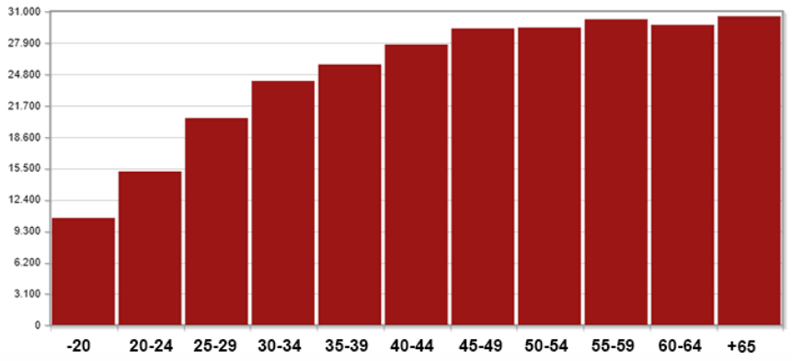
Source: Enterat (2024)
More specifically, 85% of workers in Spain earn less than €40,000 per year (of which 10% earn less than €15,000). Another 5% earn between €40,000 and €46,600. Another 10% earn more than €46,600 (El Diario, 2024).
Living areas: Spain ranks sixteenth among the countries with the lowest population density in Europe. 79% of the Spanish population lives in municipalities with more than 10,000 inhabitants, giving it a population density of 73.07 inhabitants/km².

Section 2c – HIGH LEVEL DISADVANTAGED COHORTS
- If relevant, in addition to income threshold, identify key factor of risk of not being able to access policy intervention e.g. people who live more than 20k outside an urban centre need a vehicle for private use; tenants have no control over housing adequacy

The required data could not be found, but the following table is provided:
Table 1. Households with vehicles according to whether they are eco-friendly, monthly net income level and number of household members
 | Does not have an ecological vehicle (hybrid or electric) | Own any eco-friendly vehicles (hybrid or electric) | Total
Total
Menos de 500 euros | 414.130 | 7.497 | 421.626
De 500 euros a menos de 1.000 euros | 1.905.446 | 36.383 | 1.941.828
De 1.000 euros a menos de 1.500 euros | 3.207.776 | 69.516 | 3.277.292
De 1.500 euros a menos de 2.000 euros | 2.630.321 | 85.121 | 2.715.441
De 2.000 euros a menos de 2.500 euros | 2.096.117 | 86.605 | 2.182.722
De 2.500 euros a menos de 3.000 euros | 1.490.992 | 88.564 | 1.579.556
De 3.000 euros a menos de 5.000 euros | 1.800.445 | 150.148 | 1.950.594
De 5.000 euros o más | 572.950 | 71.813 | 644.763
Source: INE (2021)

Section 2d - DISADVANTAGED COHORTS BY DIMENSIONS
DIMENSION 1
AFFORDABILITY - The ability of the person/household/company in question to cover the expenses and logistics incurred by the policy intervention, without placing a burden on the household expenditure that will require a reduction or cessation of the consumption of essential services or incur debt/drain savings.

DATA FOUND:

Table 2. Gross annual salary by age group and gender
Age group | Men (euros) | Woman (euros) | Ratio women/men (%)
Menos de 20 años | 12.436,56 | 8.875,09 | 71,4
De 20 a 24 años | 16.337,24 | 13.789,84 | 84,4
De 25 a 29 años | 21.445,91 | 19.343,03 | 90,2
De 30 a 34 años | 25.682,23 | 22.361,32 | 87,1
De 35 a 39 años | 28.111,80 | 23.237,09 | 82,7
De 40 a 44 años | 30.671,43 | 24.734,92 | 80,6
De 45 a 49 años | 31.900,79 | 26.507,49 | 83,1
De 50 a 54 años | 32.660,09 | 25.939,04 | 79,4
De 55 a 59 años | 33.190,54 | 26.928,34 | 81,1
De 60 a 64 años | 32.125,91 | 27.217,22 | 84,7
65 y más años | 35.612,02 | 25.437,34 | 71,4

DIMENSION 2

SOCIAL ACCESSIBILITY – This refers to the combined necessary social infrastructure (e.g. broadband access, enough solar panel installers) and skills (e.g. digital literacy) to enable access to the item.

List the social infrastructure is necessary to enable access to the item? Are there particular groups of people that are at particular risk of not having access to the social infrastructure? (e.g. X% of rural dwellers do not have adequate broadband access; availability of PV installers; free or low cost digital skills training for people over 65) – list these. Only qualitative notes needed.

Social Infrastructure | Excluded from accessing and why
EV charging stations | Uneven distribution of infrastructure across Spain. The highest concentration is in Madrid, Cataluña, Valencia and Andalucía. The first three regions also show the highest rates of EV registration in the last year.

The current number of 39.000 EV public charging points needs to be significantly increased to meet the demands of electric mobility in Spain. Additionally, the high concentration of public charging stations in Madrid Autonomous Community, Cataluña, Valencia Autonomous Community and Andalucia with 58% of all national base, increases regional disparities in access to electric mobility. The report also raises concerns about the current practice requiring users of electric charging points to download and register on the app of the service provider to use the service, the procedure that adds additional accessibility barriers (Payment Innovation Hub, 2025)

List the skills are necessary to enable access to the policy intervention. Which cohorts experience difficulty or ease acquiring the skill and why:

Not applicable for Spain, the access to subsidies is universal, the only limitation is the availability of public funds.

DIMENSION 3
GEOGRAPHICAL ACCESSIBILITY – The ability to reach and use required resources in a safe, environmentally sustainable and legal way that does not negatively impact individual and collective wellbeing, health, and integrity, allowing connectivity to basic services.

The distribution of EV charging infrastructure is uneven across Spain. The highest concentration is in Madrid, Cataluña, Valencia and Andalucía. The first three regions also show the highest rates of EV registration in the last year.

National distribution of public charging points (ANFAC, 2025).

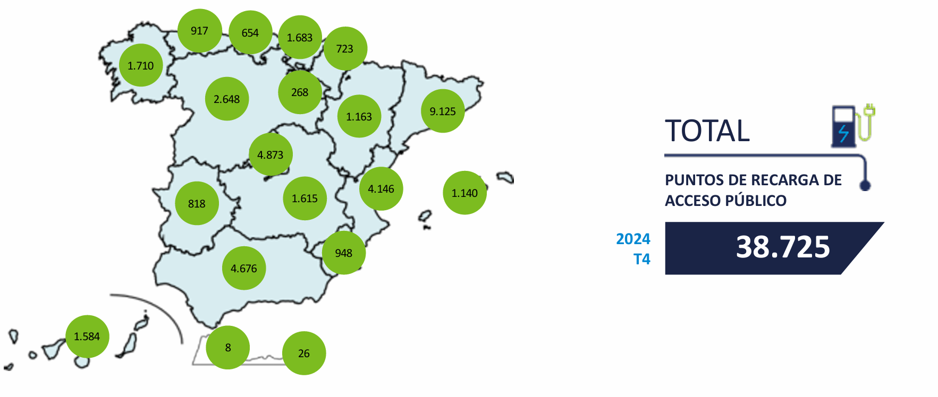

Short term geographical impact of not having access to the item – which groups are particularly disadvantaged and why:

Residents of regions lacking enough EV charging pints to address the demand of electric mobility.

Medium term geographical impact of not having access to the item if FACTOR 1 and FACTOR 2 in place (e.g. if active, public and shared mobility schemes were not put in place and car tax on fossil fuel vehicles increased by X%). If you do not have the knowledge and understanding at present it is ok to leave this blank.

DIMENSION 4
RELIABILITY - Dependability and predictability of a service/supply/demanded action or requirement in terms of environmental sustainability, time, capacity, speed, and/or usage.

Some level of critical thinking skills are necessary here. For example re electric vehicles – that the disadvantaged cohorts cannot afford the upfront costs is a given. But assessing ‘reliability’ in terms of transport accessibility – means that we can argue that under current policy provisions rural dwellers are particularly at risk of unreliable transport accessibility. Even if OECD best practice was implemented they would still need a vehicle for private use and current policy provisions do not recognise this – low income rural dwellers will be ‘left behind’???
Based on your knowledge and understanding:
What are the main barriers to reliable provision of the item to consumers?
Which cohorts are particularly at risk of ‘unreliable’ provision of the item?

The recent report on Transport Poverty in Spain (OTLE, 2025) highlight low-income households, residents of rural, suburban and low populated areas, elderly people and people with reduced mobility as most impacted by transport poverty. Most of these groups rely on old cars without environmental label whose access is restricted to low-emission zones in cities with a population over 50.000.
DIMENSION 5
Health, Safety and Environmental Sustainability - The impact of policy intervention adoption on individual and collective wellbeing which arises ether directly, as its consequence, or indirectly, as part of the wider policy environmental in the medium to long term.

Background information
Looking at how the policy is currently structured - and based on your knowledge and understanding:
POSITIVE IMPACTS
What are the immediate positive health, safety and environmental sustainability impacts of the policy intervention? Note – these may be limited or non-existent dependent on the structure of the policy intervention.

- Individual level:
Electric mobility is climate-friendly and economical.
- Collective level (this refers to local, national and global communities):
Cleaner cities, phasing out of fossil fuels and of contaminating old vehicles.
What are the medium to long term positive health, safety and environmental sustainability of the policy intervention? Note – these may be limited or non-existent dependent on the structure of the policy intervention.
- Individual level:
Electric mobility is climate-friendly and economical.

- Collective level (this refers to local, national and global communities):

Cleaner cities, phasing out of fossil fuels, new green jobs.

NEGATIVE IMPACTS
What are the immediate negative health, safety and environmental sustainability impacts or risks of the policy intervention? Note – these may be limited or non-existent dependent on the structure of the policy intervention.
- Individual level:

Dependance on cars instead of public transport options.

- Collective level (this refers to local, national and global communities):

Dependance on cars instead of public transport options.

What are the medium to long term negative health, safety and environmental sustainability of the policy intervention? Note – these may be limited or non-existent dependent on the structure of the policy intervention.
- Individual level:

Dependance on cars instead of public transport options.

- Collective level (this refers to local, national and global communities):

High traffic congestion levels, less focus on public transport infrastructure development.

Note 8 – policy environment refers to the policy under consideration (e.g. switch to electric vehicles) in the context of the wider overall policy (e.g. transport policy). When thinking about health concerns think about the impact on air quality, water availability, biodiversity loss etc which may be impacted by current policy focus and will have an impact on people’s health in the medium to long term.

Based on your knowledge and understanding:
As the policy environment is currently structured which groups are most disadvantaged in terms of their health and connectivity to basic services in the immediate or short term? What are the key short term risks to their health and connectivity to basic services?

The usual most disadvantaged groups (low-income households) are not able to access the purchase of clean electric vehicles, perpetuating their dependence on old vehicles.

As the policy environment is currently structured which groups are most disadvantaged in terms of their health and connectivity to basic services in the medium to long term? Take into account the costs of not accessing the policy intervention but also the costs of the intervention itself e.g. to local communities living next to batter production facility. What are the key medium to long term risks to their health and connectivity to basic services?

The usual most disadvantaged groups (low-income households) are not able to access the purchase of clean electric vehicles, perpetuating their dependence on old vehicles.

APPENDIX A

FITTER: available data for step-by-step template (AB, 12/05/2025)
- Focus: Irish case study but most data should be available for other countries
- affordability + house ownership for accessibility energy/housing sector
CSO: individual data on earnings (Ireland only, income from work)
- Mean and median annual earnings – gender and age group NSA81
- Earnings of parents with children (to include single parents) by education and gender EAPI03
- Earnings by gender and nationality NSA92
- Earnings by nationality and NACE sector of employment NEA09
EU SILC: Household data (available from CSO but should be same in all case study countries)
- Income and sex (median/mean income only) SIA60
- For decile distribution: SIA88
- Income and age group (median/mean income only) SIA61
- For decile distribution: SIA89
- Income and tenure status (median/mean income only) SIA66
- For decile distribution: SIA94
- Income and rural/urban location (median/mean income only) SIA67
- For decile distribution: SIA95
- Census (household data)
- Tenure status and age group of reference person: F2004
- Urban/rural and income (EU SILC): https://www.cso.ie/en/releasesandpublications/ep/p-urli/urbanandrurallifeinireland2019/income/#:~:text='Rural%20areas%20with%20high%20urban,areas'%20(%E2%82%AC29%2C424).
Other CSO:
- Disability survey – income (median/mean) and disability: APD04
Eurostat (mix of household data and individual data):
- Median saving rate by age of the reference person - experimental statistics icw_sr_01
- Distribution of population by group of citizenship and tenure status (population aged 18 and over) ilc_lvps15
- Mean annual earnings by sex (2022)
earn_ses22_27
- Tenure status by level of disability (owners only) hlth_dhc010
- Mean and median income by age and sex
ilc_di03

All of the definitions below are open to further development.

